IT24101658

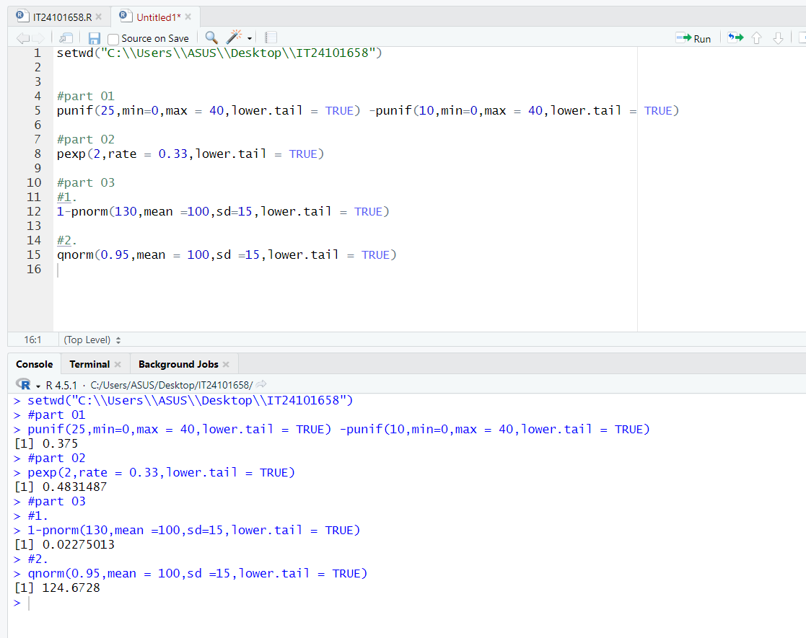Randeni R.M.S.M.